Create & Facilitate Enjoyable Learning Experiences for Young Muslim Children

Create & Facilitate Enjoyable Learning Experiences for Young Muslim Children
Malikah Muhammad, Educator/Facilitator

Sunnah Connections

Serving Umbrella for Neighbors in Need and Advancement of Humanity

January 2018

Create & Facilitate Enjoyable Learning Experiences for Young Muslim Children 1

ABSTRACT

How can we create and facilitate interactive Islamic activities which are meaningful and memorable for young children? This workshop will provide some of the answers and demonstrate how to incorporate existing ideas within your lesson plans. You will be inspired to think more creatively while experiencing a variety of approaches to keep your students interested and engaged. This workshop is not lecture based; it is participatory for educators and home schooling parents of preschoolers ages four and five.

Create & Facilitate Enjoyable Learning Experiences for Young Muslim Children 2

INTRODUCTION
In the Name of Allah, The Most Gracious, The Most Merciful
While relying upon our own smartness does not always work, humbling oneself by asking “The Expert” Al Hakim (The All Wise); Al Alim (The All Knowing) before embarking upon any endeavor works 100% every time. Allah is The Best at providing understanding and giving guidance; have that one on one conversation with Allah (The Most Compassionate) and expect amazing results. Prophet Musa (AS) spoke with Allah to gain the upper hand against Pharaoh and Prophet Ibrahim (AS) spoke with Allah to understand who is GOD. May we increase our communication with Allah and may Allah increase our knowledge and understanding on how to “Create & Facilitate Enjoyable Learning Experiences for Young Muslim Children.” Ameen.

Expanding My Personal Creativity
When creating and guiding children through wonderful learning experiences, we first begin with ourselves; adjust our lens (viewpoint); create wonderful environments our students want to learn in; expand our classroom beyond the walls of the room; be conscious of the various learning styles when planning each lesson and activity; simplify if necessary complex subjects but, remember to modify the content for students with pre-knowledge; start our lessons with the “Wow Factor!”; be flexible and adapt our plans if necessary; collaborate with teachers and parents as they are untapped human resources;
Create & Facilitate Enjoyable Learning Experiences for Young Muslim Children 3
Beginning with ourselves: We have to find the inner child within ourselves. This can be done through silly exercises to help dust off the cobwebs on our imagination. Why? Imagination is needed for creativity, and being creative is a quality which comes from Al Khaliq (The Creator) “A well-developed imagination is at the center of a child’s creativity. Without the ability to conceive new images, dream up new approaches to the world, and think new thoughts, a child will never fully experience the creativity that is his or her birthright.” (Activities and Games pg. 57)
Adjust our lens (viewpoint): Imagine if for one day we decided to try on one of our Creator’s attributes for a day. “ Allah is Al Kareem (The Most Generous), so I am going to be more generous with people I meet today.” What does it look like to be generous? Have you ever noticed we all have either small amounts or sizable quantities of Allah’s attributes within us? This won’t seem so ridiculous to imagine as a teacher once you have read Surah Al ‘Alaq (The Clot). It describes the process in which our souls come on earth. Learning about Allah through His Attributes is the magnifier for increasing our understanding of who He is.
Create wonderful environments - A spacious room is an ideal canvas to work with, but sometimes we have small spaces. You will require less contents within the room, but need to expand your boundaries within the building. Create a calm and peaceful space with warm and cool colors. Examine a color wheel to help with identifying a choice for one accent wall. Sprinkle plants around the classroom to soften things up. Be sure you grow some vegetables as well. The plants will help your students to grow. Visit a Reggio, Montessori and Waldorf school to stretch your creativity. Stay open-minded and take only the ideas you need.
Create & Facilitate Enjoyable Learning Experiences for Young Muslim Children 4
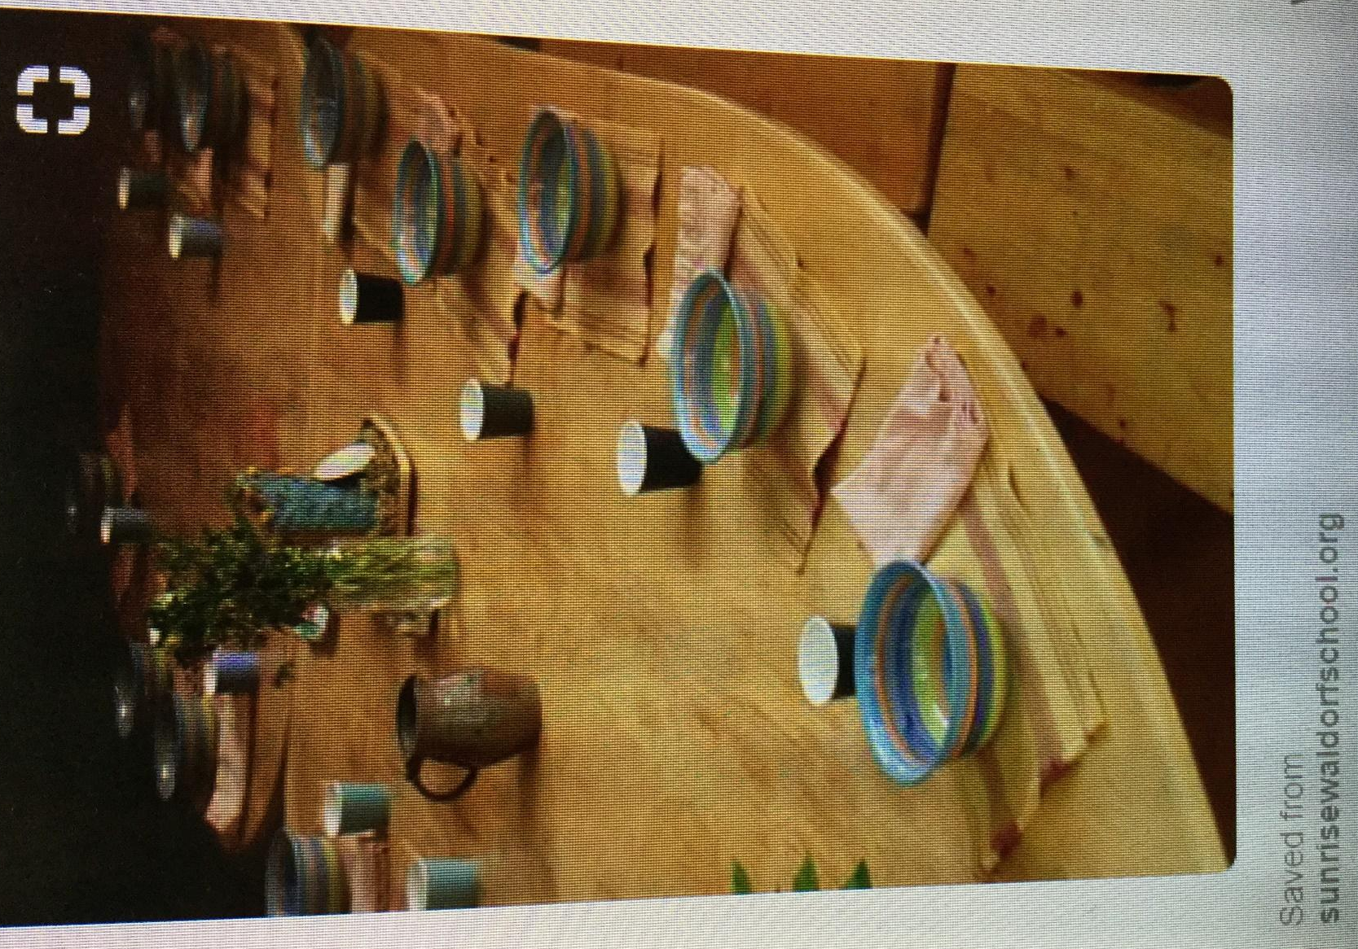
Create & Facilitate Enjoyable Learning Experiences for Young Muslim Children 5
Expand our classroom: The classroom can extend beyond your immediate room and into the halls, outdoor parks, the streams, galaxy, the universe, etc. Create other spaces for students learning. A change of environment can eliminate boredom and revive interest.
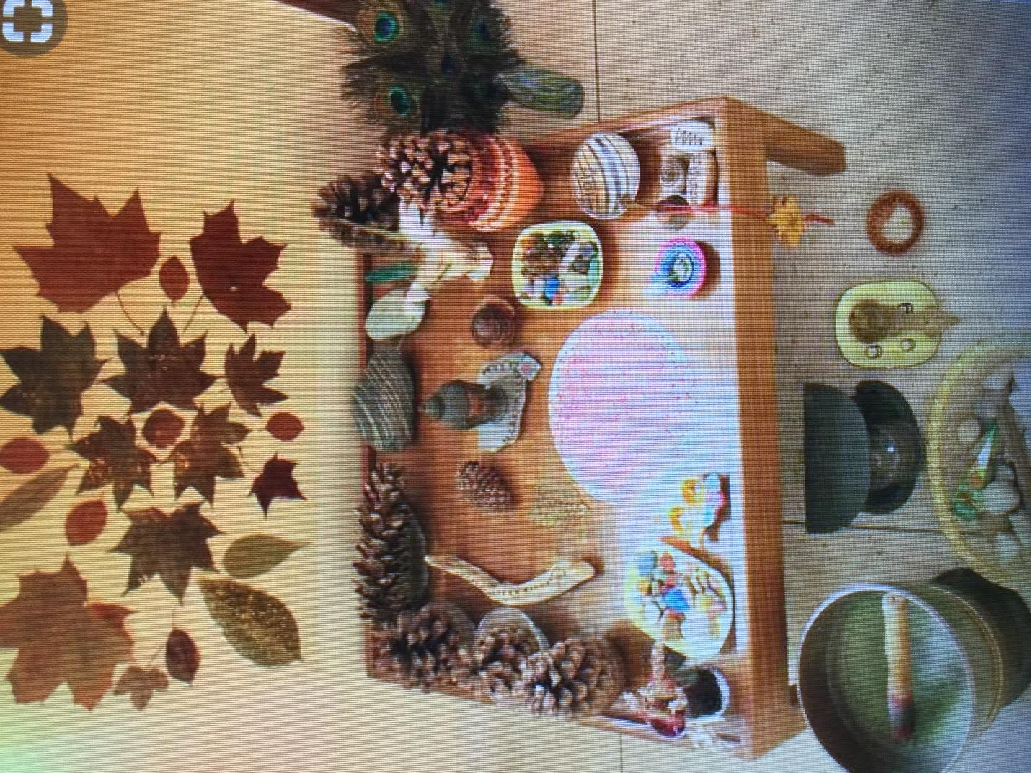

Create & Facilitate Enjoyable Learning Experiences for Young Muslim Children 6
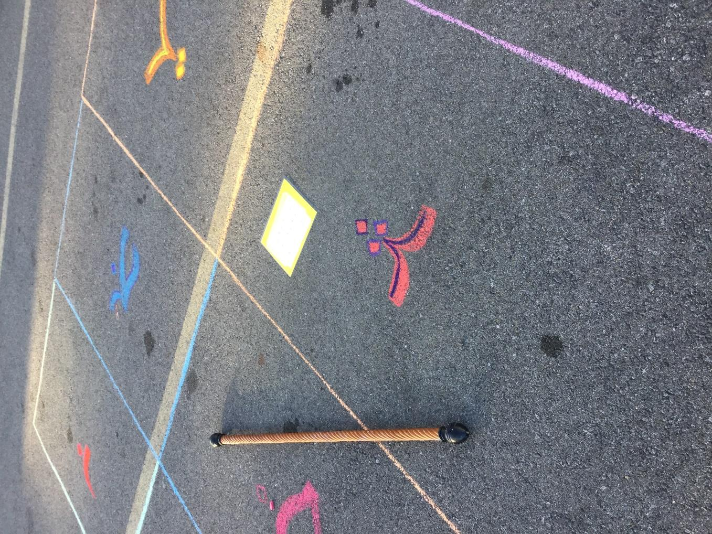

What? In this game. students were learning the varying forms of the Arabic alphabet as a way of reviewing and reinforcing the letters previously presented in the classroom lesson. A teacher can also use words from curriculum materials.
How? The students stand outside of the square. When a teacher says a letter, students scramble to get into the right square. The teacher shows the correct letter by holding up an image of the letter; he/she calls the next letter.
Tips? Create more than one grid outside for the varying levels. Train your volunteers and/or teacher aides to help you execute lessons.
Create & Facilitate Enjoyable Learning Experiences for Young Muslim Children 7
Be conscious of Learning Styles
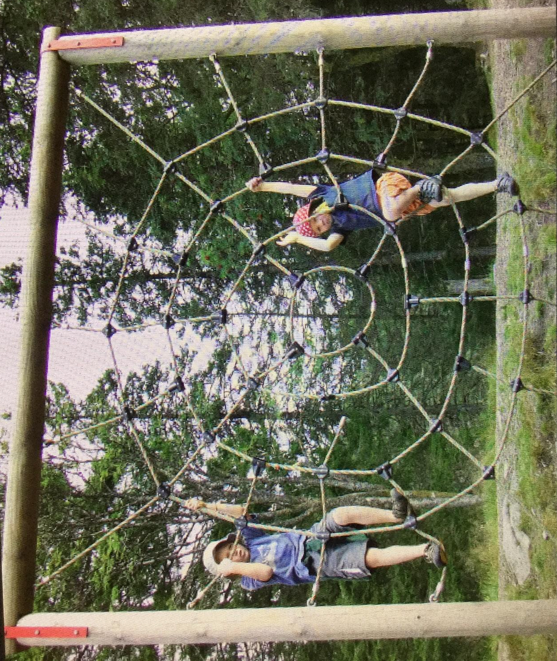
The Learning styles are visual, auditory, tactile and kinesthetic (movement). Allah states, “He created the senses...” Sura 23: 78” If we have them, we must utilize them.

Create & Facilitate Enjoyable Learning Experiences for Young Muslim Children 8
“The Wow Factor!”
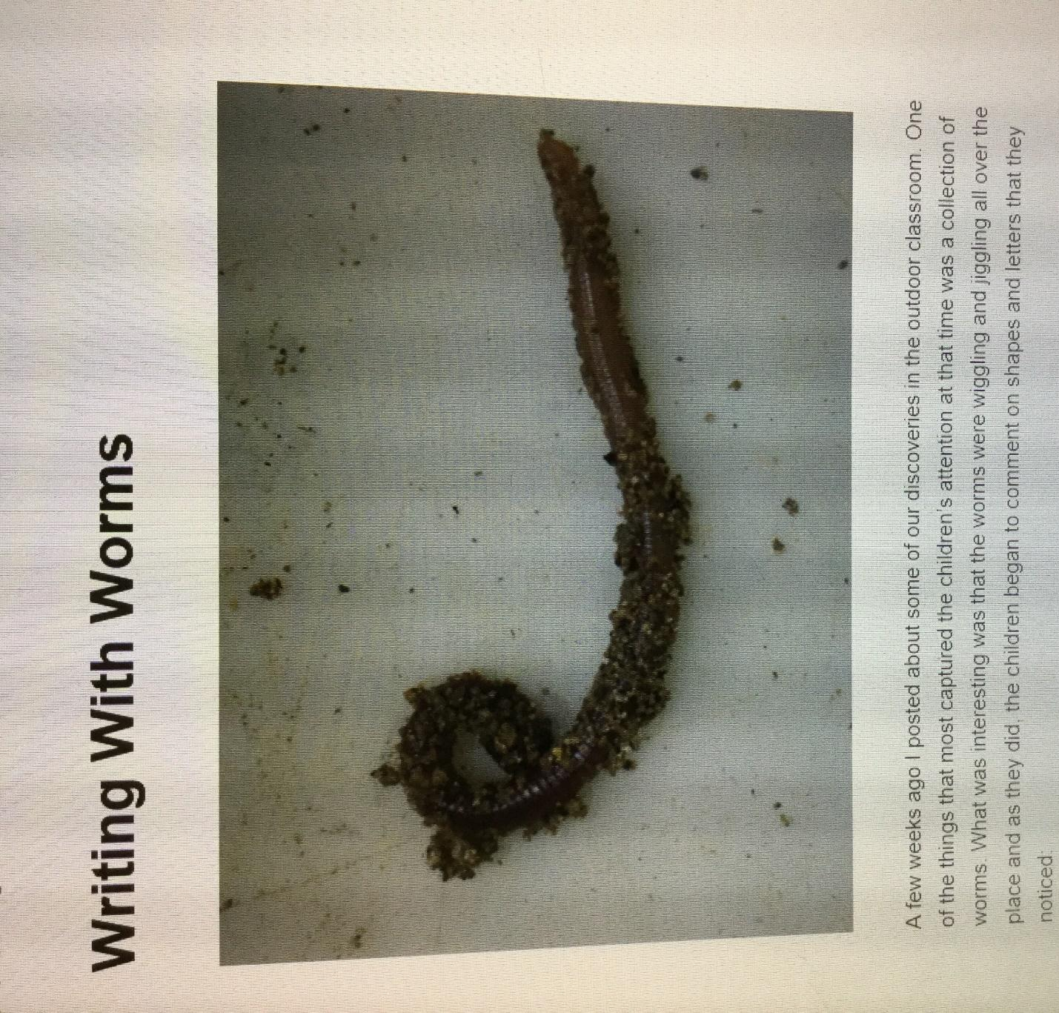
Everything in Allah’s Creation has “The Wow Factor!” Did you know trees communicate? Can you guess how they communicate? Yes, I did discover the answer and must say, Allahu Akbar! Allah is Greater than that which He created.
Create & Facilitate Enjoyable Learning Experiences for Young Muslim Children 9

Simplify Complex Topics & Accommodate Students with Pre-knowledge: Quran can be complex, but there are ayahs that are very simple and straight to the point. Look for the more simplistic ones and add more complexity to the lesson to accommodate those students with previous knowledge when they enter their classroom. Some examples are as follows:
Surah Al Araf - Ayah 57: Allah Moves the Clouds (simplistic)
Surah Al Araf - Ayah 57: Allah Moves the clouds to a land which is dead/dry/without life (added information)
Surah Al Araaf - Ayah 57: And it is He who sends the wind (simplistic)
Surah Ar Rad – Ayah 13 The Thunder praises Allah and so do the angels (simplistic)
Surah Ar Rad – Ayah 17. He sends down the rain (simplistic)
Surah Ar Rad – Ayah 17 He sends down rain from the sky (simplistic)
Surah Ar Rad - Ayah 17: He sends down from the sky the rain and valleys flow according to their capacity/only what the valley can hold. (more complex)
Lessons and activities will evolve. For example: What are clouds?; How does Allah move the clouds?; Let’s Go Cloud Watching!; Great Cloud Creations with Water Coloring; Shaping Clouds – using cotton balls and glittering grey, white and blue paints; We can Move like Clouds!

Create & Facilitate Enjoyable Learning Experiences for Young Muslim Children 9
Be Flexible and Adapt if Necessary: You may need to transition into another activity if your students are bored. Stop for teachable moments and experience Allah’s creation.
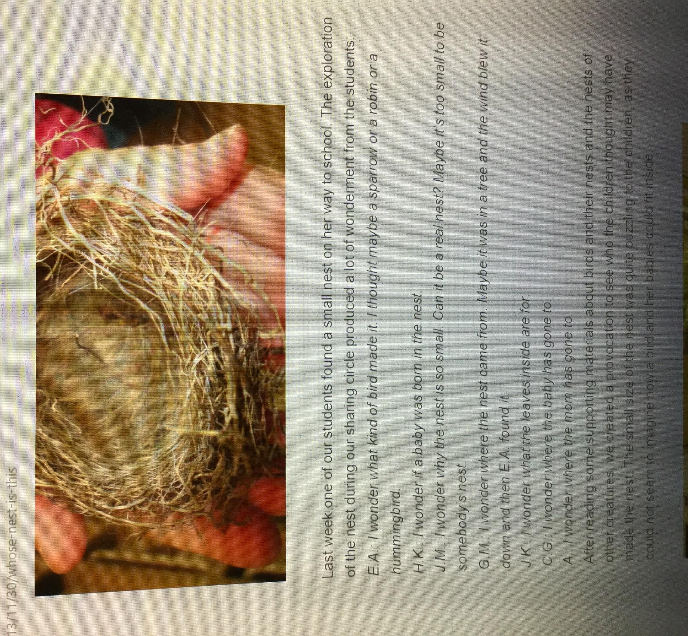

Create & Facilitate Enjoyable Learning Experiences for Young Muslim Children 11
Collaborate with the untapped Human resources
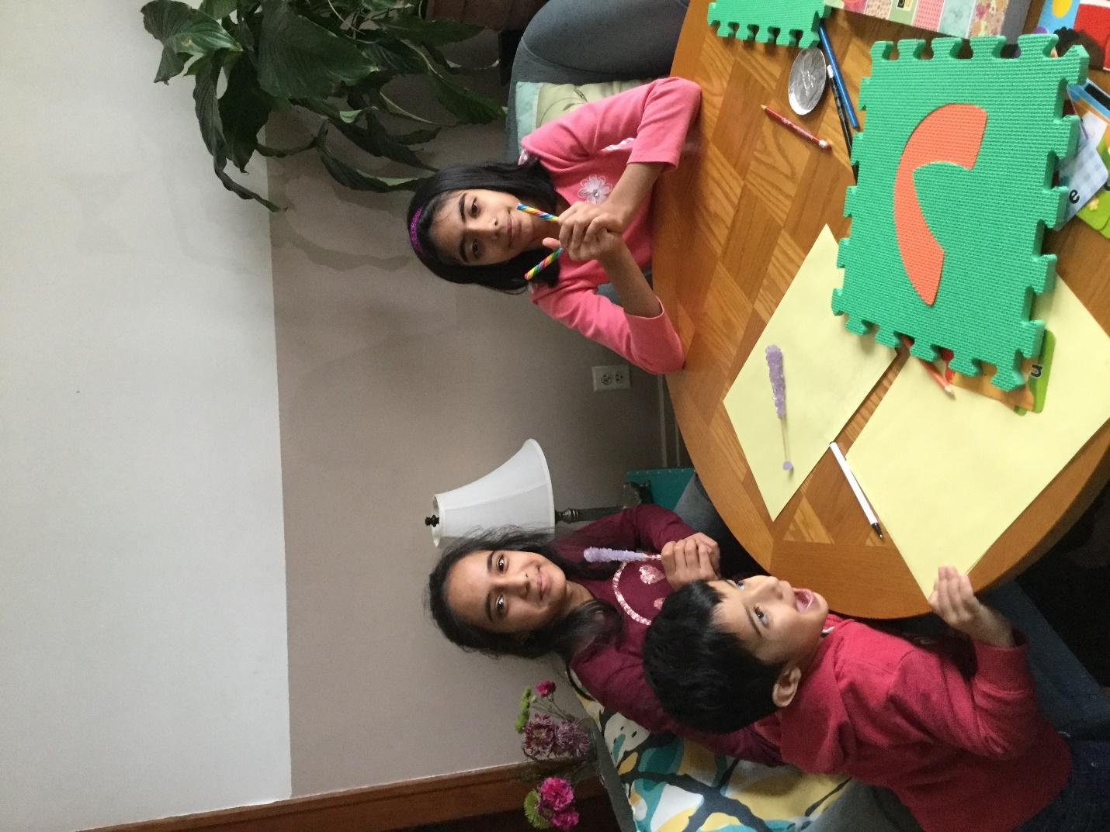
Take cues from your students and parents who are coming as gifts from Allah into our community. These students came by to help me trace some Arabic letters for the wall.

Create & Facilitate Enjoyable Learning Experiences for Young Muslim Children 12
Think back to the Aqiqa (welcoming of the infant). We were hopeful about the contributions the child will bring in the future, but forget they are a full of resources. We smile when we unwrap a gift; yet forget to smile at each other. Those grown ups we walk by without giving the greetings of peace and a smile are gifts from Allah to our community. So, don’t forget to smile and extend a heartfelt “As-Salaamu Alaikum wa Rahmatullah!” and get to know each other. I wonder how many unwrapped talents, skills, knowledge go unopened every year.
WHAT TO EXPECT?
Expect to come into an environmental sample of things to have in your learning space; to dust off the cobwebs and find your inner child. Inshallah, we will learn to not be afraid of silliness; we will start smiling again. Your students will love learning from you. This technique is called Acting Age Appropriate” As, your facilitator, I am obligated to lead by example and share my own personal story of “Hanna Hen’s Experience with Gossip & Backbiting.” You will become familiar with potentially unfamiliar vocabulary since this story is in Chicken Language and has some Arabic terminology. You’ll experience the flow of a lesson and how to transition everyone into the next activity. Did you know? Allah (swt) understands the languages of all creatures and animals that exist and gifted Prophet Sulaiman (AS) the ability of understanding the languages of animals. How awesome it would be to know animal languages. Anticipate, seeing how skilled you are at translating animal languages. This is a silly brain warm-up exercises to limber up the mind. It gets people feeling comfortable with working together and helps us to overcome the “silly factor” according to the authors of Facilitation: A door to creative leadership. Welcome to adventure Muslim Explorers!
References
Miller, B., Vehar, J., & Firestien, R. L. (2001). Facilitation: A door to creative leadership. Williamsville, NY: Innovation Resources, Inc.
Muslim Spotlight: Hana Hen YouTube accessed January 9, 2018 https://youtu.be/wKgj_ypY69s

