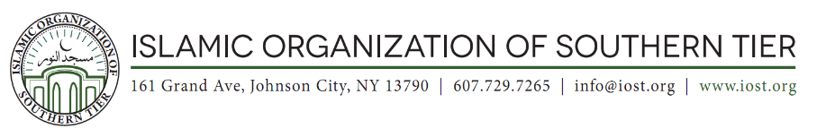

IMAM POSITION

The Islamic Organization of the Southern Tier has been serving the needs of the Muslims in the Greater Binghamton, New York, area for the past 40 years. The Board is seeking an Imam who will provide spiritual leadership at the IOST. He will lead Juma’a and daily prayers; provide guidance and counseling; establish and promote educational and extracurricular programs for adults and youth; and engage in inter-faith activities. The Imam will report to the Board of Trustees.

The ideal candidate has a bachelor’s degree, or equivalent, in Islamic Studies, or a related field; is a Hafiz; is fluent in English and proficient in Arabic; and has strong interpersonal skills. He has the attitude and ability to teach Quran and Islamic studies and work with people of different cultures and backgrounds.

A compensation package commensurate with background and experience will be provided. Only US Citizens or Green Card Holders will be considered.

Please send a cover letter and resume to the IOST Board at esiddiqui7@aol.com. For more information about IOST or this position, please call 607.759.2699.

