Precise and Systematic Approach to Improving Student Learning
Students have the right to receive instruction at their zone of proximal development for learning to take place. Using assessment tools and data helps educators identify the right level of instruction for students, regardless of their place on the continuum level of ability and achievement.
Every educator needs to ask themselves – are my students learning? It used to be that we talked a lot about differentiation, but instructors were not provided with a lot of resources or focus for that. Using data from different assessments effectively and extensively can provide the support needed to focus. Teachers will have a way to focus to develop a plan for how to use their time for either intervention with students that need it, or providing enrichment to challenge those higher level students.
When instruction is designed, and driven using data from the different assessment tools effectively, then teachers can help students set challenging and achievable goals that can propel them toward proficiency and beyond by helping them to know what is possible. It is often ignored that all students cannot follow the same learning path with identical goals. Educators should use the data from different sources of testing to streamline teaching strategies to provide differentiated instruction through flexible grouping.
At the very onset of the school year, the student needs to be assessed and an individual growth chart should be prepared. Traditional tests only provide the basic assessment of the child being at, below, or above level. Schools should consider a test that can narrow down a student’s needs as to the exact objectives a student needs to master. Knowing this curriculum can be targeted to their specific needs. This data should be used throughout the school year for the student to monitor their growth.
What Good Assessments Do
Without setting expectations based on real data, educators simply can’t plan for and support the growth of every child. Fair and accurate assessment tools that empower educators to provide this are absolutely integral to achieving equity in our classrooms.
Educators use assessments to take the guesswork out of questions around a student’s academic performance. Assessments answer questions around student growth with data. They are designed for various purposes, but fall into three broad categories.

Formative Assessments | Curriculum Based Assessments | Summative Assessments
Formative assessments provide information in the moment to help teachers adapt instruction; this process helps to collect critical information about student progress and to uncover opportunities for review, feedback, and adjustments to instruction. | Curriculum Based assessments provide an objective measure of student achievement, progress, and growth over time; the results can be used to differentiate instruction, allocate resources, determine placement in special programs, and evaluate program effectiveness. These assessments are given at regular intervals through the school year. | Summative assessments provide a summary of contextualized student achievement after completion of an instructional unit or course, including accountability tests at the end of a semester or school year.
Used to judge if a student understands a critical concept | Used to track growth and adjust individual instruction over a period of time | Used to confirm a student’s proficiency according to a national or state standard
Seeing Beyond the Negative
It’s quite difficult to find statistics that paint a flattering picture of education in America. What’s worse, the scary numbers dominating the headlines simply do not reflect our common purpose of creating better lives for all our children. Let’s take a closer look at an example of a “scary number.”
According to some statistics, up to 70% of students are not achieving proficiency on today’s summative tests. If that’s true, then the first step in fixing it is for teachers to know those students’ starting points in order to set goals and guide their progress. (N. (2014). Assessment Matters. Retrieved January 25, 2017, from https://www.nwea.org/resources/assessment-matters-report-2014/)
Along the way, a student still may not be rated as proficient on summative assessments, but this does not mean that he or she is not growing academically. In reality, the real story isn’t the “scary number,” but the substantial growth of that student—the unsung gains that informed, dedicated teachers make with students all along the spectrum of achievement.
What if the narrative of real growth replaced all those scary numbers? How would that change everyone’s perception of education in our classrooms and encourage the growth that eventually eclipses the scary numbers altogether?
The fact is that, thanks to assessment, we can actually see heroic growth. Consider the fifth grade student who starts the year reading at a second grade level. In June, his teacher rightfully celebrates his achievements because he is now reading like a fourth grader—still not proficient, but growing remarkably. We believe that is a cause for celebration, and without properly assessing growth, that bright window might just have remained shut.
Imagine if we applied the same myopic negativity to business. If a start-up has yet to reach the break-even point, but shows consistent positive growth in sales and market share, is that really “bad news” for investors? Our students deserve recognition for their progress, and our society requires a clearer picture of what our schools accomplish every day.
Design a Test
- Align test questions to content standards
The first requirement to measure student achievement and growth fairly and accurately is that the questions that make up a particular test reflect the content of the standards.
- Match question difficulty level to student ability
After creating a vertical scale, you must match item difficulty to student ability. Assessments that restrict questions to grade level standards alone have an important role in providing information the teacher needs to assess student proficiency in the curriculum objectives. However, when assessments are restricted in this way, we are not able to precisely identify where students who are performing above or below grade level actually achieve—and this represents many, if not most, of our students. How can we achieve real equity in the classroom if educators cannot chart a path forward for low-performing students or continue to encourage growth in high performers?

Growth Data
Gather data for different goal setting purposes:
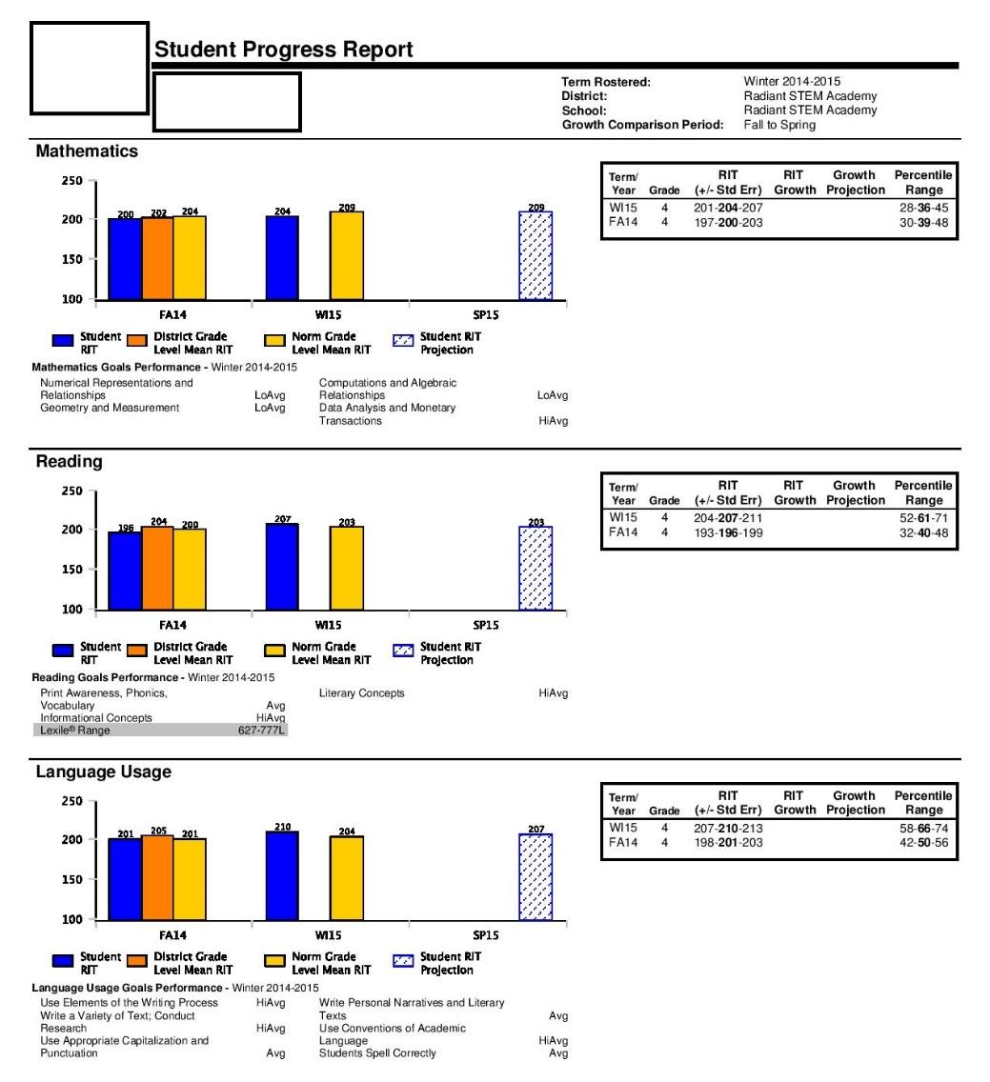
Student Growth

Learning Continuum
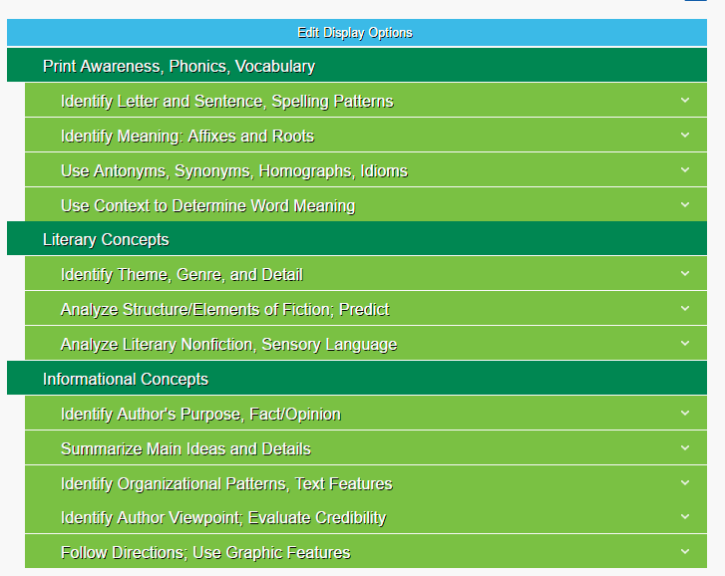
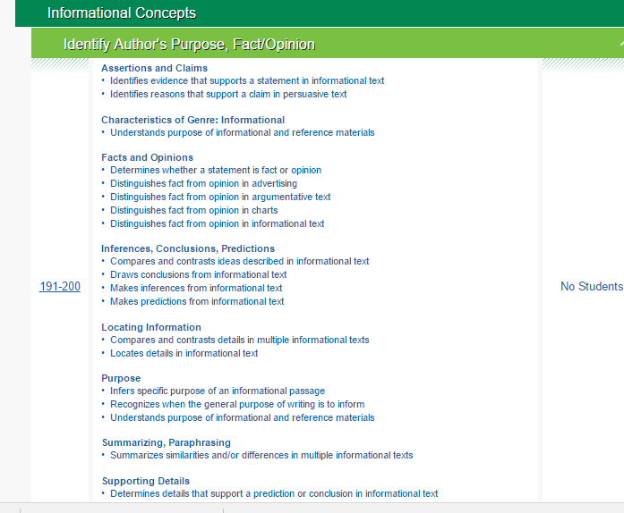
Partnering to Help All Students Learn
Accurate measurement of student achievement over time along a vertical scale allows educators to accurately determine academic growth for all of their students, but that’s just the beginning of the story. The insights of teachers, parents, administrators, and the students are all critical to the interpretation and usefulness of the data. Growth data can help all stakeholders answer important questions about student learning.
- Teachers can learn what kind of progress their students are making toward agreed-upon
- learning goals, and how to adjust instruction to meet student needs
- School principals can ensure that the students in their schools are tracking toward key
- milestones, then offer the best professional development to support teachers in their use of
- timely growth data
- Administrators can evaluate their school’s programs for improvement planning. What’s working best? What isn’t working at all?
- Parents can learn how their child is progressing and take an informed, active role in growth
- Students can gain the knowledge of their progress and get a clear idea of what they need to work on to continue reaching their goals
Support for Students and Teachers - Evaluating Achievement and Setting Goals
Step 1: After gathering information from the data analysis, set up conferences with teachers for intervention
Strategies.
Step 2: Once achievement goals are set using data, the teacher and student should analyze the strengths and opportunities. One should be careful to choose just a few objectives to develop into specific student goals for mid-year and then end of year to assess progress.
Step 3: Create grouping charts to map proficiency and for documentation. It is important to note that if the desired results are not achieved within a set time frame, then it will be necessary to adjust intervention strategies.

Bibliography
N. (2014). Assessment Matters. Retrieved January 25, 2017, from https://www.nwea.org/resources/assessment-matters-report-2014/

