Bringing Arabic Language to Life with Interactive Teaching Strategies
Wafaa Atalib, Hanan Mahmoud, Rana Issa, Mayssaa Nori, Marwan Hassan
A presentation for the ISNA Education Forum 2017

Abstract
In the presentation, Bringing Arabic Language to Life with Interactive Teaching Strategies, we will discuss the advancement of instruction, practice, and assessment in the Arabic language classroom. A discussion of the importance of setting aside traditional methods of teaching Arabic as a Second Language in Islamic Schools, and incorporating interactive Arabic teaching strategies will be introduced. Activities, such as games, interactive notebooking, and hands on activities, will be explored. This workshop will be given in Arabic and English to meet the needs of the attendees. Also, attendees will be able to follow along with a few activities and take home ideas to use the next day in class!

Bringing Arabic Language to Life with Interactive Teaching Strategies
Introduction
Teaching Arabic as a second language in classrooms across the nation pose various challenges for the native Arabic speaking teacher. Instructional strategies for non-Arabic speaking students can often differ from native Arabic speaking students. All students, being raised in the U.S., require the Arabic and Quran teacher to dig deep into the strategy toolbox in order to keep the curriculum engaging and exciting. Adding the following three key strategies can aid in facilitating second language acquisition and ensuring student success.
Strategy 1: Using Quranic Arabic to Teach Reading Comprehension
When approaching Arabic instruction, it is important to remember the connection between Arabic and Quran. Using Quranic Arabic to teach Reading comprehension is beneficial and achieves several goals at one time. Students can learn the vocabulary and meaning through Quranic Arabic, and learn how to use the same words in the Modern Standard Arabic language. This will help the students relate to the Quranic Arabic and apply it in their daily lives.
Reading and writing are closely tied together when learning the Arabic language. The goal is for the learner/student to gain the necessary skills to effectively read and comprehend the classical Quranic style of literature. It is essential to understand the difference between the ability to read and comprehend. The idea behind this approach is to provide the students with the necessary skills to help understand and comprehend the content.
Through the years of teaching the Arabic language, it has become evident that teaching Arabic language based on a topic or theme derived from a Surah is one of the most effective ways for a student to master the Arabic language. Using the Quran to teach the Arabic language also helps the students to master many objectives at one time. This teaching strategy will facilitate learning Arabic and understand the context of the Quran.
Strategy 2: Differentiating Instruction-
Differentiated instruction techniques accommodate each student’s learning style, readiness, and interest. These strategies require a variety of teaching methodologies to provide students the same information in multiple ways. They may also require teachers to teach content at varying levels based on students’ readiness. The goal of differentiated instruction strategies is to ensure that all students are engaged in the learning process by providing tasks to help each individual student reach his/her fullest potential. Some of the examples of differentiating instructions in an Arabic classroom are as follows: Flexible grouping, learning centers, and independent study.
A comparison between old and new student assessments is provided in this short presentation. It provides new methods to keep students’ engaged, and as effectively as possible. Different procedures are explained on how students should be tested during the year. New tools and videos are presented to show the effectiveness of some exciting activities that the students love to engage in.
In the past, assessment usually took the form of a pencil-and-paper test written after the unit was taught. Today, assessment is recognized as an ongoing process taking many forms. Forms of assessment in an Arabic classroom could be formative and/or summative. Some examples may be projects such as plays, skits, nasheeds, and paired conversations. Creating cooperative group activities are essential components to assessing language acquisition in the Arabic classroom. For example, students work in small groups to put words in order to create a story or assemble parts of a Surah. This activity differentiates by having students the language orally and auditorily through speaking to each other, visually by reading the words, and kinesthetically by sorting. An activity can act as a formative or summative assessment.
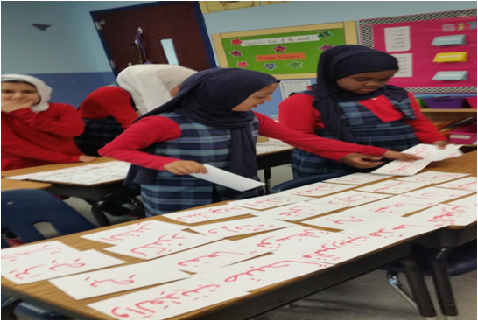
Strategy 3: Interactive Notebooking
What are Interactive Notebooks and how do they look in an Arabic classroom? Interactive notebooking is a way for students to personalize their work. Using an easily found composition notebook or journal, a student turn written concepts into visuals, increase independence, make meaningful connections, and work cooperatively with other students in the class. Interactive notebooks also act as a classroom window for parents to “see” what’s going on in the classroom.
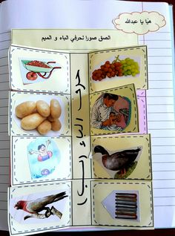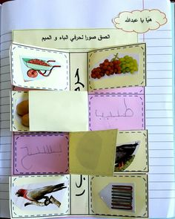
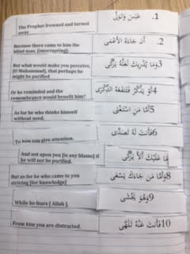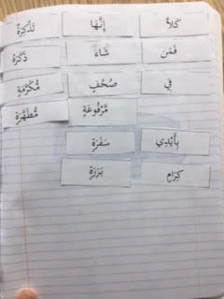
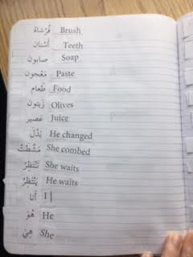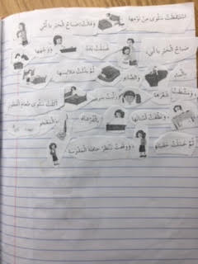
Conclusion
As teachers, is essential to continuously grow and adapt instructional practices in order to meet the students’ needs. Arabic teachers, in particular, are challenged with the goal of infusing the Arabic language, as well as culture, into instruction with high quality, engaging lessons. Using Quranic Arabic, incorporating new ways of assessing student progress, and adopting interactive activities are a few ways to achieve this goal.

References

Bees and flowers. (n.d.). Retrieved March 03, 2017, from http://mrswilliamsonskinders.blogspot.com/2012/05/bees-and-flowers.html
B. (1970, January 01). Interactive Science Journals for Young Learners. Retrieved March 03, 2017, from http://teachinglearningloving.blogspot.com/2013/08/interactive-science-journals-for-young.html?m=1
Home. (n.d.). Retrieved March 03, 2017, from http://interactive-notebooks.wikispaces.com/
Integration of assessment in lesson planning for Arabic teaching/ by class Road. August 2011.
(n.d.). Retrieved March 03, 2017, from http://www.bayyinah.tv/
Kosnik, Alice. Powerful strategies for differentiating instruction in your world language classroom. Bureau of education and Research.
Lynette, B. R., Says, L., Says, P. I., Says, A., Says, R. S., Says, J. S., . . . Says, K. (2016, October 14). 7 Reasons to Use Interactive Notebooks. Retrieved March 03, 2017, from http://minds-in-bloom.com/7-reasons-to-use-interactive-notebooks/
Teacher Bits and Bobs. (n.d.). Retrieved March 03, 2017, from http://teacherbitsandbobs.blogspot.com/search/label/science%20notebooks
Wilson, S. (1970, January 01). Math Journal: "Tools for your Toolbox". Retrieved March 03, 2017, from http://missvanmarensfantasticfirstgrade.blogspot.com.au/2012/08/math-journal-tools-for-your-toolbox.html

