Focusing on What Learners Can do in the Arabic Language Classroom
Helena Curtain Ph. D.
ISNA Education Forum, Chicago, March 25, 2015
hcurtain@uwm.edu helenacurtain@gmail.com
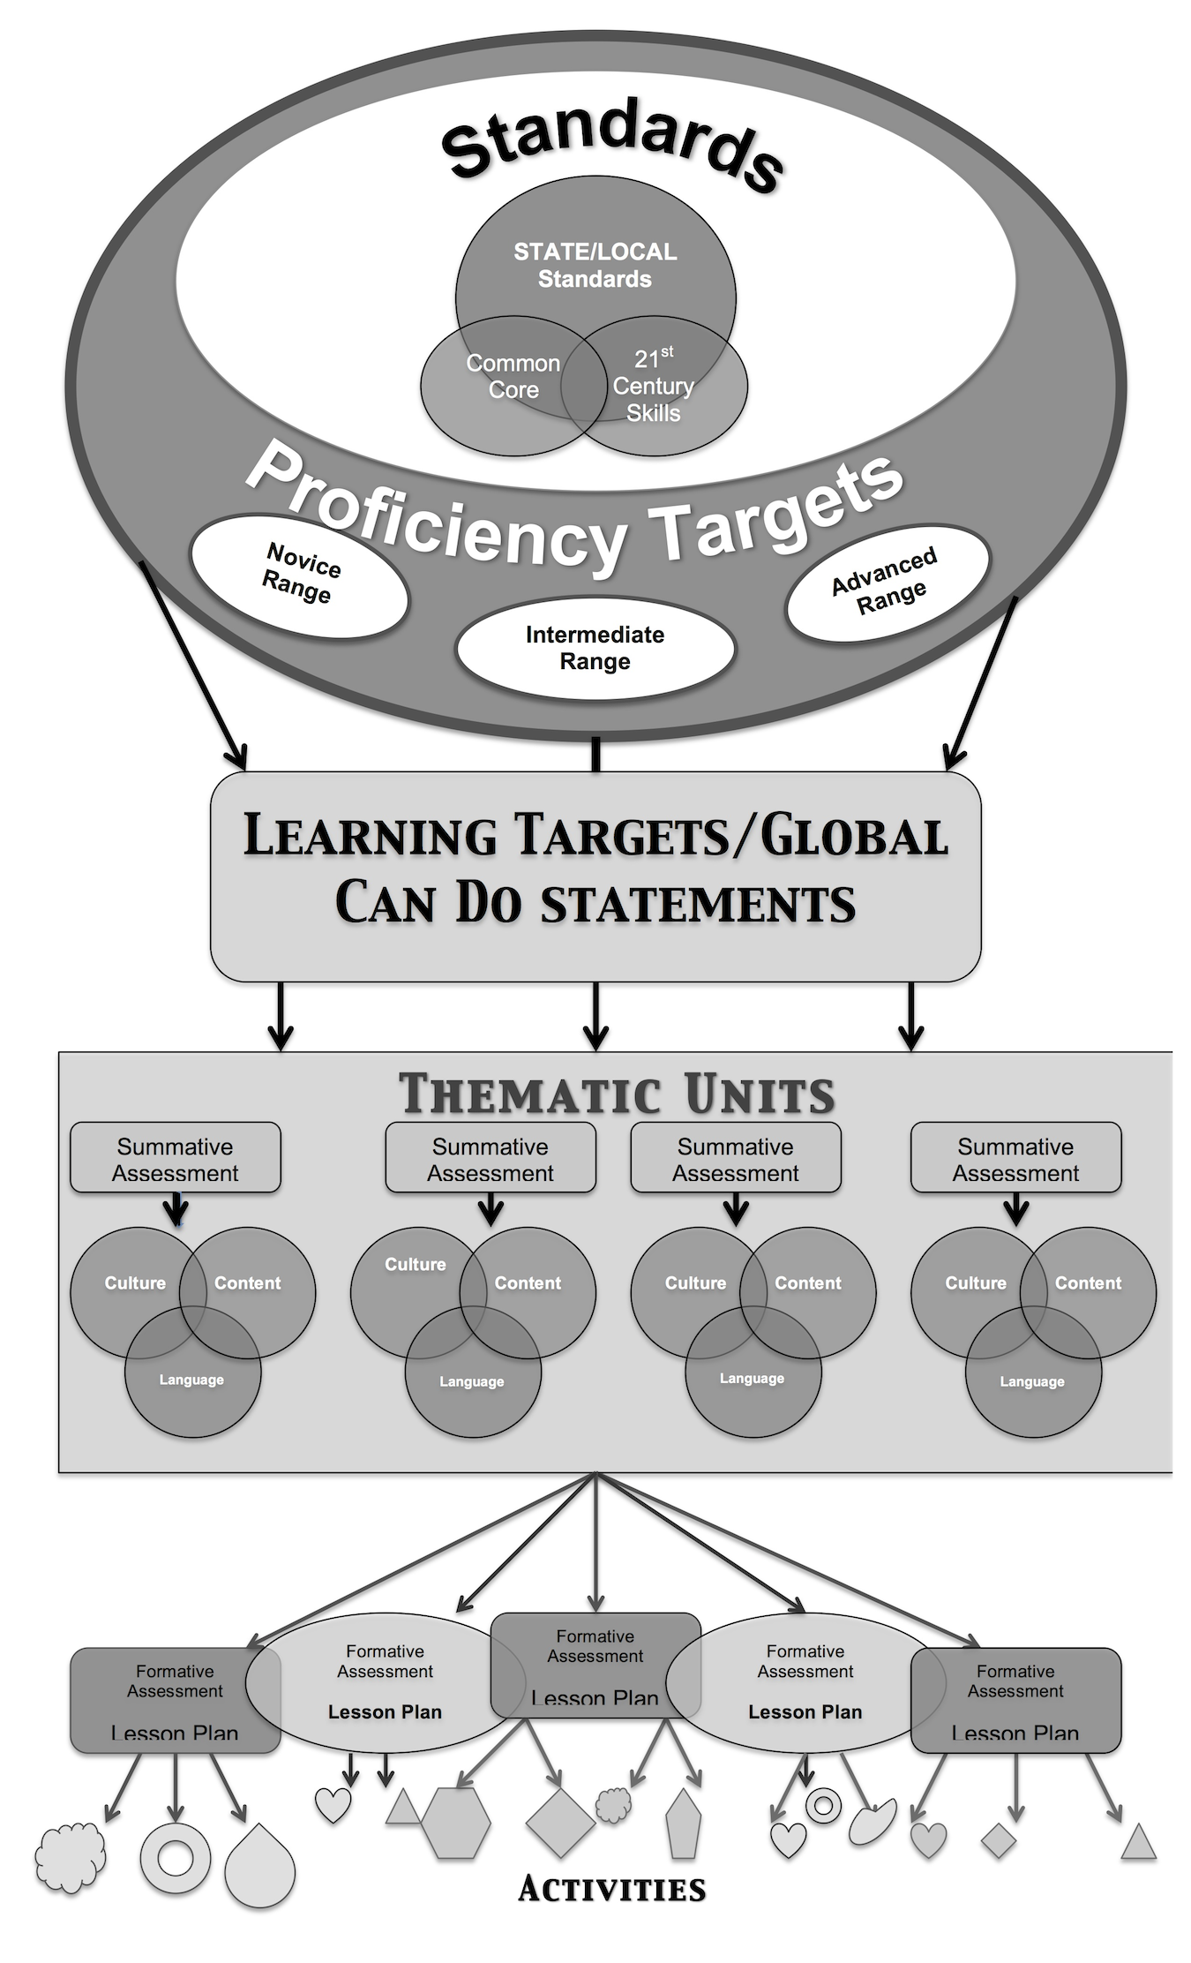

Unit Title/Theme: ____________________________________________________ Language: ____________
Level/Grade: _________ Unit Duration, Weeks: __________ Minutes/Hours Per Week: _______________
Scenario: (Optional): _______________________________________________________________________
Annual Proficiency Target
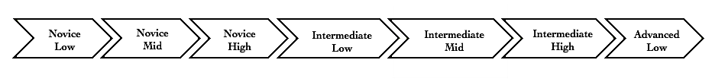
Unit Learning Targets 

What will learners be able to do with what they know?
Central Idea | (The underlying concept (Big Idea) that guides the unit theme and provides for deeper learning )  Students will understand that….
Unit Focus Question(s): | (The question(s) will students be able to answer by the end of the unit.)
Targeted Standards/ Benchmarks  (Global/General) | (Overarching standards or benchmarks (national, state, local) addressed in the unit. You can chose the NCSSFL/ACTFL Global Can Do Benchmark(s) and/ or you can choose common core standards or standards/benchmarks from other curriculum areas. )
Learning Targets  (Customized Can-Do Statements specific to the unit. listed according to each communication mode) | Here list specific, customized learning targets/Can-Do statements here that flow from the targeted benchmarks in the section above. This section lists what students will be able to do functionally. List of what students must know in order to accomplish the Can-Dos is in the last section of the template (“Unit, Language, Culture, and Content Components.”)
Interpretive  Listening/Reading |  | Interpersonal | Presentational  Speaking/Writing
I can: |  | I can: | I can:

Unit Performance Tasks 
How will learners demonstrate what they can do with what they know?
Interpretive Assessment (Summative)  Listening and Reading | Interpersonal Assessment (Summative)  Person-to-Person | Presentational Assessment (Summative)  Speaking and Writing

Major Activities

What MAJOR learning activities will prepare students to demonstrate what they can do with what they know?
In this section list the major activities. This does not take the place of lesson plans but provides a plan for how the unit is structured. This section helps to show how the unit will flow and pinpoints the most important activities in the unit. Many of these activities will also function as formative assessments.

Beginning (What activity will hook the students’ interest in the unit? How will you start the unit to motivate students?)

Middle (List only MAJOR unit activities related to the learning targets. Do not list all the activities that you would do in each lesson plan. Formative assessments should be listed here.)

End (What activity will end the unit and give students a feeling of accomplishment? This is the unit culminating activity. And could be one or more of the unit performance tasks from above.)

Breakdown of Language, Content, Culture Components

Language
Language Chunks  Phrases and sentence frames | Essential Vocabulary  Critical Words | Structures (Grammar)  To support functions
List the phrases & sentence frames here. | List only the most essential vocabulary here. | List the grammar that students will need to support the communication.

Culture
Products , Practices, Perspectives and Cultural Interactions

Content Connections
Academic Skills and Processes (Bloom, Theory of Knowledge, etc.) | Content (Connections to General Curriculum)
List skills such as classifying, comparing and contrasting here. | List the curriculum connections to other subject areas here.

Materials and Resources 
Digital | Print | Props/Realia/Manipulatives

Filling in the Unit Plan Template
What follows is a detailed explanation on how to complete a Unit Plan. The components listed here may vary in the way that they are laid out in the unit plan format that is used, but the elements are the universal elements that the template should contain. These elements can be placed within a curriculum-mapping framework such as Rubicon Atlas.

Scenario (Optional)
This is a short description in a few sentences summarizing the unit, including the beginning and end. This is helpful when you are sharing your unit with other teachers.

What will learners be able to do with what they know?
Targeted Standards: These are local standards and benchmarks. They are usually global, overarching statements. This section may also include standards from the Common Core and from other curricular areas.

Learning Targets: These are the very specific “Can Do” statements that clearly say what the students will be able to do with what they know by the end of the unit. (These targets are always stated in terms of what the students will do and not in terms of what you are going to teach). The NCSSF/ACTFL Global Can Do statements are organized around language functions and are a very helpful starting point. Five basic overaraching language function are Socializing, Exchanging Information, Getting Things Done, Expressing Attitudes, Organizing and Maintaining Communication . The number of learning objectives will depend on your unit. Remember that the learning targets must be observable and must specify what the students will be able to do. Use action verbs such as identify, describe, demonstrate, explain, and classify to help you in this process. Remember also that in order to make the unit deep and rich, you want to be sure to include culture and the academic skills and processes that are part of the content of the general curriculum. The unit should enable students to communicate about meaningful topics. Those topics can come from the language alone, from culture, and from the academic curriculum of other subject areas.

How will learners demonstrate what they can do with what they know?
Performance Assessments At various points in the unit (Assessments do not all have to take place at the end of the unit.), students will complete performance assessments that show that they have mastered the learning targets. It is important to provide an assessment for each of the three communication modes: interpersonal, interpretive, and presentational. A rubric that clearly spells out the expectations should accompany each assessment.

Preparing learners to demonstrate they can do with what they know

Major Learning Activities
This section of the template contains major learning activities in the unit. It does not list every partner activity, game or exercise. Completing this section helps you to see the flow of the unit. This is not a complete plan for all the activities but a general framework for the major activities of the unit. In the “Beginning” section, list how you will start the unit in order to motivate students. In the “Middle” section, list the MAJOR unit skill-building activities. In the “End” section, include how you will close the unit and indicate the culminating activity. You will list the remaining unit activities when you write your lesson plans. Many of these activities will also function as formative assessments.

Unit Language, Culture and Content (What Students Know)
Language Chunks (Phrases and sentence frames)
List the language chunks and phrases. This is important so that the goals of the unit go beyond the single word level by asking students to speak in phrases and sentences. Once the students have learned these language chunks they can continue to build proficiency by combining them with connecting words such as and, but, because…

Essential Vocabulary (Critical Words)
List the essential vocabulary for the unit. You do not have to list every word, but be specific about the vocabulary so that the scope is clear. For example, say, “Adjectives such as tall, short, cold, hot” rather than simply “Adjectives.” This column helps you identify the scope of the vocabulary for the unit

Structures (To Support Language Functions)
List the grammar the students will be using in the performances for this unit. The grammar goal for the unit supports the communication goal. Students need to have opportunities to practice the grammatical structures within a meaningful context. Students need to use and practice the grammar, rather than learn it through analysis and drill.

Culture Here list the cultural components of the unit.

Content Connections
Here list the academic skills and processes from Blooms Taxonomy or the Common Core. In the content section list the topics from other content areas such as social studies or science.

Essential Materials/Resources: What materials will you need to complete the unit? List books by name and author, name songs, and give Web addresses. Be as specific as possible. Remember others will want to benefit from your unit.

Note: Organizing what you will teach by using a Unit Plan Template helps you see that you are emphasizing the elements that will meet the standards and benchmarks of your curriculum. Creating a thematic unit is not a linear process—it is more of a spiral. At every step along the way, we need to monitor and adjust our work, so that it reflects the characteristics and content of good unit design.

Sample Lesson Plan Template

Proficiency Target: _______________

What will learners be able to do with what they know by the end of this lesson?
DO  What are the learning targets for this lesson? (Can dos) | KNOW  What vocabulary, grammatical structures, language chunks, cultural knowledge, and content information do learners need to accomplish the lesson learning target(s)?

How will learners demonstrate what they can do with what they know?

What will prepare learners to demonstrate what they can do with what they know?

Opening/Activity 1:

Activity 2:

Activity 3:

Activity 4:

Closing/Activity 5: Note: the number of activities is not fixed.

Materials

Resources:
http://www.actfl.org/publications/guidelines-and-manuals/actfl-proficiency-guidelines-2012

http://www.actfl.org/sites/default/files/pdfs/Can-Do_Statements_2015.pdf

NOTES on the Lesson Plan

What will learners be able to do with what they know by the end of this lesson?

DO What do you want students to be able to do at the end of the class? This should be a real-life use of language.
KNOW What vocabulary, structures and/or culture do students need to know in order to do what you have targeted?

How will learners demonstrate what they can do with what they know?

How will you know that students can do what you targeted as a performance? What will they do to demonstrate that to you?

What will prepare learners to demonstrate what they can do with what they know?

Do the activities in the lesson …
- Provide sufficient opportunities for understanding new words before expecting production?
- Provide multiple, varied opportunities for students to hear new words/expressions used in highly visualized contexts that make meaning transparent?
- Provide students with an authentic purpose for using words and phrases?
- Engage ALL students (VS. just one or two at a time)?
- Give students a reason for needing to/wanting to pay attention and be on task?
- Vary in the level of intensity and physical movement from one to the next?
- Represent the best possible use of instructional time?
- Take an appropriate amount of time considering the age of the learner?
- Make the learner the active participant and not the teacher?
Additional thoughts as each activity is envisioned . . .
- What will the teacher be doing during the activity?
- What will the student be doing?
- How long will the activity take?
- What materials / resources does the teacher need to have available?
Adapted from Greg Duncan and Mimi Met, 2008

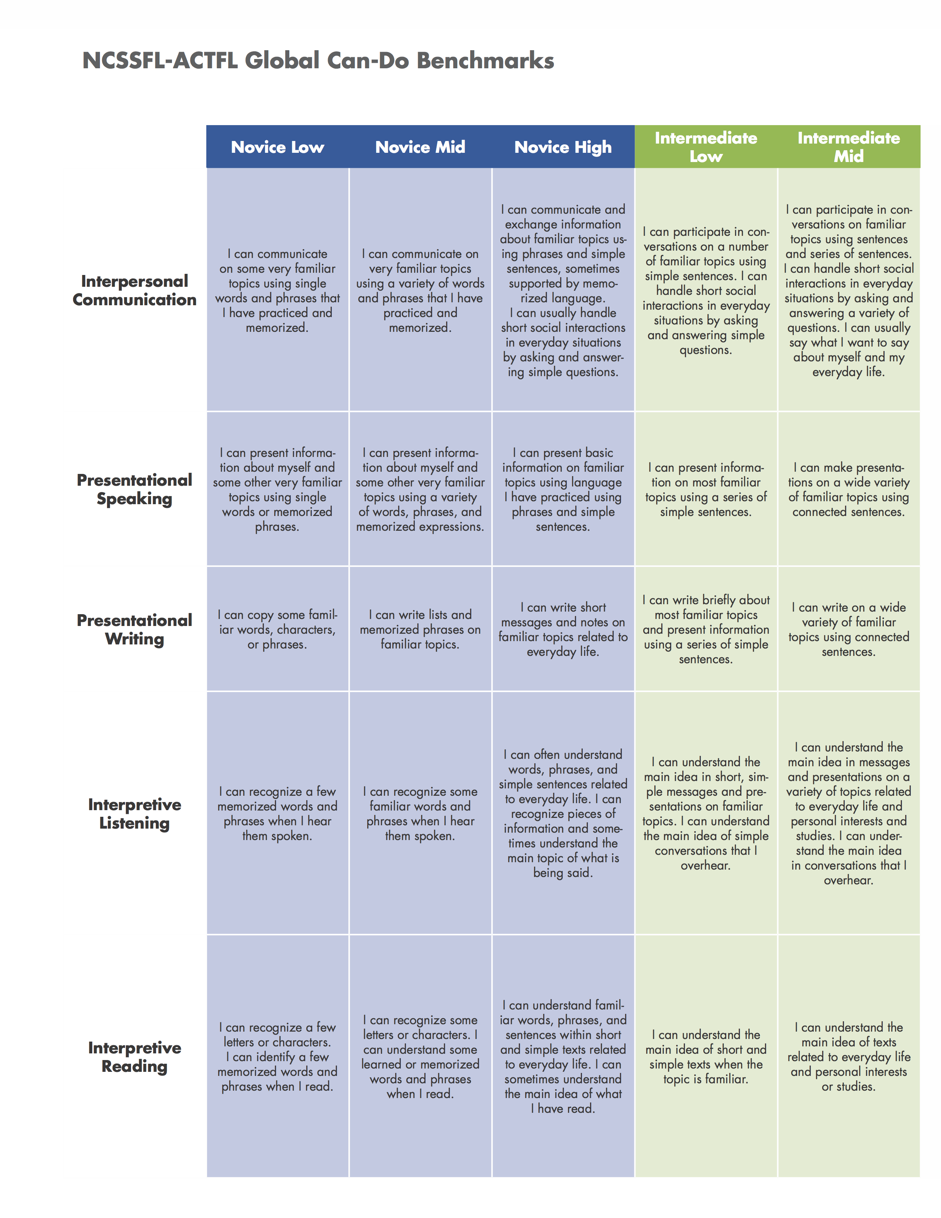

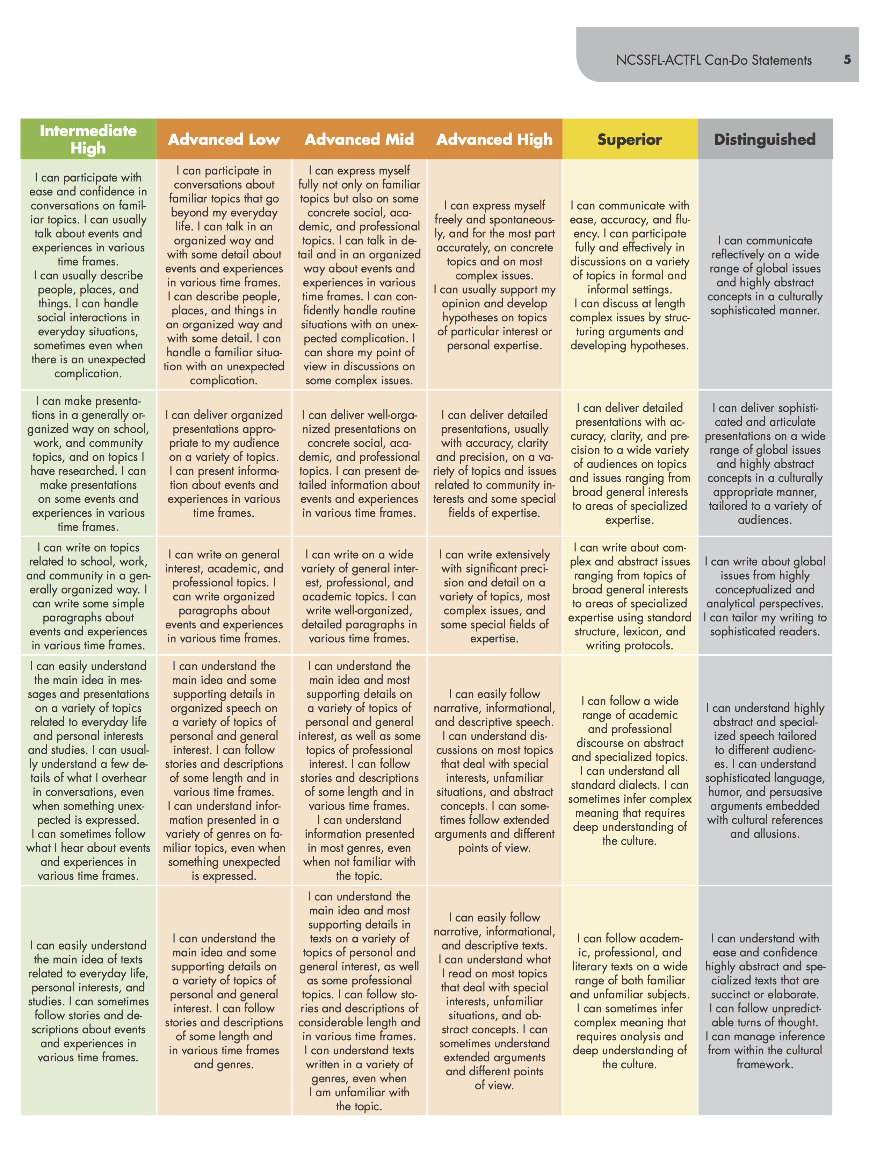

World Language Program Proficiency Targets (All Modes)
 | Elementary School |  |  |  |  |  | Middle School |  |  | High School
Elementary School | JK SK | Grade  1 | Grade  2 | Grade  3 | Grade  4 | Grade  5 | Grade  6 | Grade  7 | Grade  8 | Grade  9 | Grade 10 | Grade 11 | Grade 12
Listening
Speaking
Reading
Writing
Middle School |  |  |  |  |  |  | Grade  6 | Grade  7 | Grade  8 | Grade  9 | Grade 10 | Grade 11 | Grade 12
Listening
Speaking
Reading
Writing
High School |  |  |  |  |  |  |  |  |  | Grade  9 | Grade 10 | Grade 11 | Grade 12
Listening
Speaking
Reading
Writing

NL, NM, NH (Novice Low, Novice Mid, Novice High)
IL, IM, IH (Intermediate Low, Intermediate Mid, Intermediate High)
AL, AM, AH (Advanced Low, Advanced Mid, Advanced High)
How Many Hours per Level ? (Typical MS and HS Schedules)
Level & total hours | 1 135-150 hours | 2 270-300 hours | 3 405-450 hours | 4 540-600 hours | 5 675-750 hours | 6 810-900 hours

Proficiency Targets and Time Allotments For Typical Middle and High School Schedules
Daily Schedule  55 minutes for 180 days 165 hours per school year  50 minutes for 180 days 150 hours per school year  45 minutes for 180 days 135 hours per school year | Block Schedule  90 minutes for 90 days 135 hours per school year  80 minutes for 180 days 120 hours per school year

